ANSWERS

QN

1. Name: 3 RCA

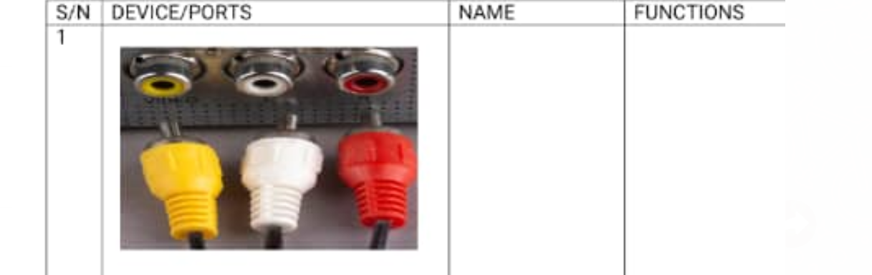

Function:

The 3rca cable is one of the types of RCA cable, which is color-coded. The yellow one is for composite video, red for the right audio channel, and white or black for the left channel of stereo audio. The trio of jacks could be found on the back of almost all audio and video equipment

2 .1Name: Printer



Function:

A printer is a device that accepts text and graphic output from a computer and transfers theinformation to paper, usually to standard-size, 8.5" by 11" sheets of paper

2.2 Name: Desktop computer

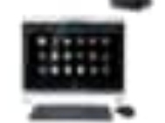

Function:

taking input data, processing the data, returning the results, and storing the data

2.3 Name: Year Phone



Function:

They are electroacoustic transducers, which **convert an electrical signal to a corresponding sound**. Headphones let a single user listen to an audio source privately, in contrast to a loudspeaker, which emits sound into the open air for anyone nearby to hear

2.4 Name: projector remote control

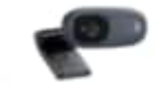

Function:

automatically adjusts position, tracking, and sync settings on projector

2.5 Name: subwoofer

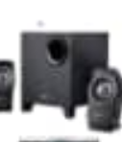

Function:

focuses on **producing the lower frequencies within music, known as the bass and sub-bass, amplified through the woofer**. While regular speakers can allow you to hear the bass, a subwoofer enables the listener to feel the sound

2.6 Name: Laminator.

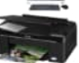

Function:

It applies a thin plastic cover to paper documents by using pressure, heat, and their internal roller mechanism. In the most common scenario, the paperwork is fed into the machine one page at a time, sandwiched between loose plastic sheets or in lamination pouches.

# 2.7 Name: Paper Punch Binder

# 

# Function:

# is an office tool that is used to create holes in sheets of paper, often for the purpose of collecting the sheets in a binder or folder (such collected sheets are called loose leaves.

# 2.8 Name: personal computer

# 

# Function

can be used to store, retrieve and process data of all kinds

2.9 Sijakion vizur

# QN 3 sijakijua

QN4 Name: ports on a computer

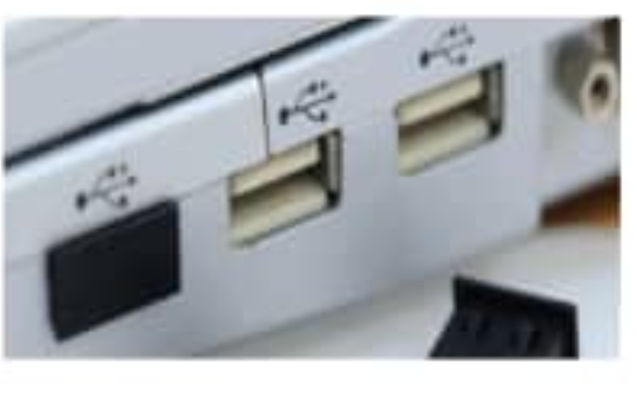

Function:

is to act as a point of attachment, where the cable from the peripheral can be plugged in and allows data to flow from and to the device

QN 5 Name: HDMI port

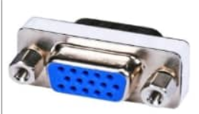

Function:

provides an interface between any audio and video source. (Such as a set-top box, DVD player, or audio visual receiver over a single cable